

MAHARASHTRA STATE BOARD OF TECHNICAL EDUCATION, MUMBAI
A Project Report on
Student Freelancer Marketplace
Submitted in partial fulfillment for the award of
Diploma in Computer Engineering

By
Narayani Satish Patil
Kaveri Devendra Pawar
Paurnima Mahesh Thakurware
Mitesh Ajabsing Padvi


A Project Report on

Student Freelancer Marketplace

Submitted in partial fulfillment for the award of Diploma in Computer Engineering
By
Narayani Satish Patil
Kaveri Devendra Pawar
Paurnima Mahesh Thakurware
Mitesh Ajabsing Padvi

Guided by
Ms. M.L. Manikhedkar




MAHARASHTRA STATE BOARD OF TECHNICAL EDUCATION, MUMBAI
S.S.V.P.S's Bapusaheb Shivajirao Deore Polytechnic, Dhule
DEPARTMET OF COMPUTER ENGINEERING
CERTIFICATE
This is to certify that,

Sr. No | Roll No | Full Name of Students | Enrollment No. | Exam Seat No.
1. | 67 | Narayani Satish Patil | 23610960250 | 405630
2. | 79 | Kaveri Devendra Pawar | 23610960265 | 405642
3. | 101 | Paurnima Mahesh Thakurware | 23610960294 | 405664
4. | 118 | Mitesh Ajabsing Padvi | 24610960308 | 405681

from S.S.V.P. S’s B. S. Deore Polytechnic, Dhule have completed Capstone Project of final year having title “Student Freelancer Marketplace” during the academic year 2023-2024. The project is completed in a group consisting of four persons under the guidance of the Faculty Guide.
Date : |  | Place: Dhule
Signature: |  | Signature:
Name : | Ms. M.L. Manikhedkar  Guide | Name : Ms. N. D. Patel  H.O.D.
Signature: |  | Signature:
Name : | External | Name : Prof. S.A. Hire  Principal

Acknowledgment

We would like to express our sincerest gratitude to all people who have contribute towards our project. We would like to extent our heartiest thanks to the Head of Computer Department, our mentor Ms. M.L. Manikhedkar and subject teacher Mr. N. D. Patel sir for their important guidance, help and advice which was really important for our overall capstone project. Also, we would like to extent our thanks to all faculty of our department and all our colleagues who helped us in completion of the project.

Your sincerely,
Narayani Satish Patil
Kaveri Devendra Pawar
Paurnima Mahesh
Thakurware
Mitesh Ajabsing Padvi

Abstract

The Student Freelancer Marketplace is a web-based application developed to manage freelancer services for different types of events such as web development, design, and writing. The main objective of this system is to simplify the process of selecting and booking freelancer services. Through this system, clients can view various freelancer listings, explore services, and make bookings easily. The system includes features such as Home Page, Login/Sign Up, Browse Freelancers, My Hires, and Hiring Status. It is developed using HTML, CSS, JavaScript for the frontend and MySQL database for storing client and hiring information. This system helps improve freelancer marketplace management and provides a convenient and organized platform for both clients and administrators.

Content Page

Chapter Number | Title | Page Number
 | Abstract
 | List of figures
 | List of tables
1 | Introduction or Background of Industry | 1-2
2 | Literature survey and Specification | 3-4
2.1 | Study of existing system / Review of research paper | 5
2.2 | Limitations of existing system / Problems discussed in research  papers | 5-6
2.3 | Problem Identification / Need of a system | 5-6
2.4 | Problem definition | 7
2.5 | Specification | 8
3 | Scope of Project | 9
4 | Methodology with action plan | 10-12
4.1 | Proposed work | 13
4.2 | Action Plan | 14-15
5 | Details of design, working and progress | 16-22
6 | Result and applications | 33-37
7 | Conclusion and future scope | 47

List of figures

Sr. No. | Title of Figure | Page No.
4.1 | Block diagram of Project Work Monitoring System | 14
5.1 | Flow diagram of Project Work Monitoring System | 17-18
5.2 | Site Map of Project Work Monitoring System | 19-20
5.3 | Admin module flow | 21
5.4 | Mentor module flow | 22
5.5 | Student module flow | 23
5.6 | Er diagram of Project Work Monitoring System | 24
6.1 | Home Page of Project Work Monitoring System | 31
6.2 | Registration form for Student | 32
6.3 | Registration form for Mentor | 33
6.4 | Login Page for Admin user | 34
6.5 | Login Page for Mentor user | 35
6.6 | Login Page for student user | 36
6.7 | Admin Home Page | 37
7 | View Newly registered student – Admin | 32
6.9 | All student list – Admin | 32
6.10 | Group management – Admin | 33
6.11 | Mentor assignment – Admin | 33
6.12 | Add Project details – Admin | 34
6.13 | Mentor Management – Admin6 | 34
6.14 | Add timeline activity - Admin | 35
6.15 | Add weekly date to activity planned – Admin | 35

List of tables

Sr. No. | Title of Table | Page No.
1 | Study of existing project management application | 4
2 | Database table description | 17
3 | Student registration form validations | 27
4 | Mentor registration form validations | 28

Chapter 1
Introduction and Background of Industry

Introduction:

Event decoration plays an important role in making projects such as web development, design, and writing more attractive and memorable. In today’s time, the demand for freelancer services is increasing as people want their events to look unique and well organized. However, many decoration businesses still manage hires and services manually, which can be time-consuming and difficult to manage.

To overcome these problems, the Student Freelancer Marketplace has been developed. This system provides an online platform where clients can explore different freelancer services, view design ideas, and make bookings easily. The system helps simplify the freelancer management process and makes it more organized and efficient for both users and administrators.

Background of the Industry:

The freelancer marketplace industry has grown significantly in recent years due to the increasing demand for well-organized and professionally completed projects. Decorations play an important role in creating a pleasant atmosphere for projects such as web development, mobile apps, design, and content writing. Traditionally, freelancer services were managed manually through direct communication between customers and freelancers. This method often caused delays, miscommunication, and difficulty in tracking project progress.

With the growth of digital technology, many businesses are now shifting towards web-based systems to manage their services more efficiently. Online platforms allow clients to explore freelancer listings, compare services, and make bookings easily. The Student Freelancer Marketplace is developed to support this growing industry by providing a simple and organized platform for managing freelancer services and project bookings
as well'. Projects mainly serve this purpose of developing learning-to-learn skills with an aim to develop the following attributes in the students:
a) Initiative and Confidence – Ability to take initiative and solve new problems.
b) Spirit of Enquiry – Developing curiosity to learn and explore new ideas.
c) Creativity and Innovation – Ability to think creatively and develop new solutions.
d) Planning and Decision-Making Skills – Ability to plan tasks and take proper decisions during project development.
e) Teamwork and Leadership – Ability to work effectively in a team and lead when required.
f) Persistence – Developing patience and not giving up easily when facing difficulties.
g) Documentation Skills – Maintaining proper records of project work and preparing a formal project report.

Capstone Project

A capstone project is an important academic activity that helps students apply the knowledge and skills they have learned during their course. It provides an opportunity for students to work on a real-world problem and develop a practical solution using their technical knowledge.

In this project, we developed the Student Freelancer Marketplace, which is a web-based application for managing freelancer services for different events. The system allows clients to explore freelancer listings, select services, and hire freelancers easily through an online platform.

The main objective of this project is to simplify the freelancer marketplace booking process and make it more organized. It also helps administrators manage hires and freelancer services efficiently.

Through this capstone project, students gain experience in system design, development, database management, and teamwork, which helps improve their technical and problem-solving skills.

Chapter 2
Literature Survey and Specification

Study of existing system / Review of research paper:

In the traditional freelancer marketplace system, most freelancer services are managed manually. Customers usually contact freelancers directly to inquire about freelancer listings, prices, and availability. This process is time-consuming and sometimes leads to miscommunication and difficulty in managing bookings.

Various research studies and web-based systems have been developed to improve project management and freelancer services. These systems allow clients to explore freelancer gig ideas, categorize events, and manage hires more efficiently through online platforms.

After studying these existing systems and research papers, it was observed that a simple and user-friendly platform is needed to manage freelancer services more effectively. Therefore, the Student Freelancer Marketplace was developed to provide an easy way for users to view freelancer services and manage project bookings in an organized manner.

Project Co-Ordinator:

Course teacher/HOD
    - Project Co-Ordinator currently take review of every group on decided day of week. (approximate 20 minute for every group).
    - Project Co-Ordinator currently need to manage attendance sheet of every member (student) in group, which further use for evaluation of every student.
    - Project Co-Ordinator currently identity work of individual student by asking some question in project demonstration at end.

Student:

Work in group of 4 student (group size may vary)
    - Student currently submit weekly diary manually to show their individual work and team work.
    - Student manage individual and group notebook for note down project work.
    - Group meet their mentor in week twice or more times and manage record by taking signature of mentor on group notebook-index page, which is further use for evaluation.
    - Each student contributes to different parts of the project such as frontend development, backend development, database design, and documentation.
    - Group note down the changes/suggestion manually said by mentor and admin.
    - Student follow the weekly action plan already define by admin.

Mentor:

Assign to every group
    - Mentor currently evaluate every member in group by remark on weekly diary manage by each student
    - Mentors manage status of every group by take review of every group and record manually on paper
    - Mentor notify every group member to see the status of project development by physically meeting Mentor currently memorize previously assigned task of every group and take proper action

Study of exiting project management application
Table 1 Study of existing freelancer marketplace/project management application

Sr No. | Application | Description
1. | Hire Freelancer | This system provides online event planning services such as venue booking, decoration selection, event planning, and vendor management. Users can explore different freelancer marketplace styles and book services online.
2. | Fiverr | This platform provides wedding planning services where users can search freelancer gig ideas, event planners, and  vendors. It helps users compare freelancer profiles  and hire freelancers directly.

Limitations of existing system / Problems discussed in research paper:
- Many freelancer marketplace services still depend on manual booking and phone communication.
- Users cannot easily compare freelancer listings and services in one place.
- Managing project postings and hires manually can lead to errors and delays.
- Lack of a centralized system to manage freelancer marketplace bookings and client details.

2.3 Problem Identification / Need of a system:

- Traditional freelancer marketplace booking process is mostly manual and time-consuming.
- Customers cannot easily view different freelancer profiles, services, and prices in one place.
- Manual hiring may lead to communication errors between clients and freelancers.
- Managing project bookings and client details manually is difficult and may cause data loss. There is no centralized system to track project bookings and freelancer services.
- Therefore, there is a need for an online system that allows clients to explore freelancer services and hire freelancers easily.

Problem definition:
The current freelancer marketplace booking process is mostly manual. Customers need to contact freelancers directly to know about services and prices, which is time-consuming and difficult to manage.
Therefore, there is a need for a web-based Student Freelancer Marketplace that helps users view freelancer services and manage project bookings easily.

Specification:

Hardware Specification:
Operating System: Windows 10 (64 bit) 4.00GB
Processer: Intel(R) Core (TM) i3-3220 CPU @3.30 GHz 3.30 GHz
Ram: 4.00GB

Software specification:
Server: XAMPP 8.0.28
Database:

Chapter 3

Scope of Project
The scope of this project is to develop a Student Freelancer Marketplace that helps users explore and book freelancer services for different events. The system provides an easy platform where customers can view various freelancer profiles, check details, and book freelancer marketplace services online.
system includes different user roles such as Admin and User. The admin manages freelancer services, project bookings, and client details. The User can view freelancer listings, select services, and hire freelancers easily.
The system aims to simplify the freelancer marketplace booking process, maintain records of bookings, and provide an organized platform for managing freelancer services.
User Roles:
1.Admin
- Manage freelancer services
- Manage project bookings
- View client details
- Updates or delete freelancer services
2. Users
- View freelancer profiles and services
- Register and login to the system
- View hiring details
Functionality
- View freelancer services
- Book freelancer marketplace
- Admin manages freelancer services
- Store client and hiring record

Chapter 4

Methodology

User Requirement:

Functional Requirement:
There are two user roles for the system: Admin and User.

Requirement of Admin:
      - Admin can login to the system.
      - Admin can add, update, and delete freelancer services.
      - Admin can view and manage project bookings.
      - Admin can view client details.
      - Admin can manage freelancer profiles and prices.
      - Admin cam maintains records of all bookings.

Requirements of Mentors:
      - Mentor can login to the system using username and password.
      - Mentor can view the list of assigned groups or users.
      - Mentor can assign task to particular group.
      - Mentor can monitor the progress of the project work.
      - Mentor can guide and review the project activities.
      - Mentor can able to view timeline defined by admin.
      - Mentor can provide suggestions and feedback for improvement.

    - Requirements of user:
- User can register and login to the system.
- User can view different freelancer services and themes.
- User can select freelancer services and hire freelancers.
- User can view hiring details and event information
- User can provide feedback about freelancer services.

Requirements of Group/student:
      - The student can login to the system using username and password.
      - The student can view project details and requirements.
      - The student can work on assigned project tasks.
      - The student can submit project work and progress updates.
      - The student shall be able to see the remark given by mentor to their submission of task.
      - The student can view mentor remarks and suggestions.

Nonfunctional Requirement:
- The system should be user-friendly and easy to use.
- The system should provide secure login and protect user data.
- The system should respond quickly while loading pages.
- The system should be reliable and available whenever required.
- The system should maintain data accuracy and consist

Block Diagram of System:
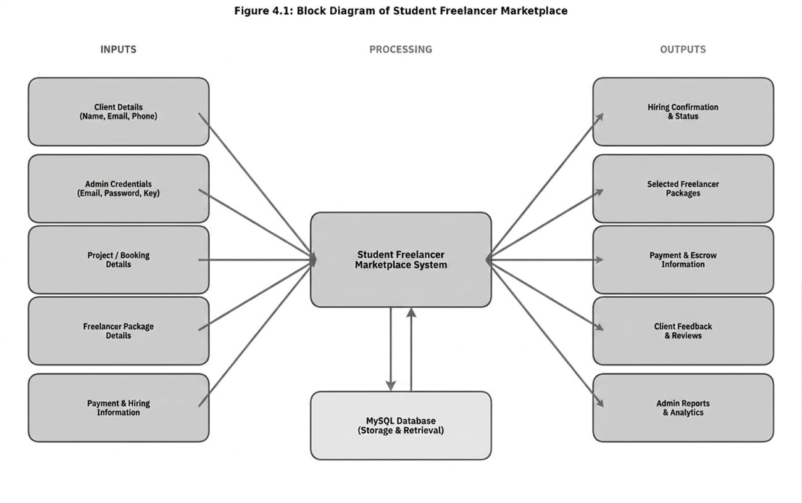
Figure 4.1 Block diagram of Student Freelancer Marketplace.

This block diagram represents the overall working of the Student Freelancer Marketplace. The system takes various inputs such as client details, admin details, project details, decoration package details, and hiring details. These inputs are provided by users and administrators to manage freelancer marketplace services efficiently. All the input data is processed by the central system, which handles operations like hiring management, package selection, scheduling, and payment and escrow processing. The system is connected to a database where all the information is stored and retrieved whenever required. After processing, the system generates outputs such as hiring confirmation, selected freelancer packages, event schedule details, payment and escrow information, decoration status, and client feedback. These outputs help both customers and administrators to track and manage project activities smoothly. Overall, the system ensures proper coordination between users, services, and data, making freelancer marketplace management easy, organized, and efficient.

Action Plan:
Steps followed to developed project work monitoring system:

- Finalization of project team and allocation of project guide
- Identify project domain/area
- Submission of project proposal/project ideas by the project team
- Finalization of project idea by project guide and HOD
- Industrial survey and Literature survey
- Project Identification and Specification
- Proposed detailed methodology of solving the identified problem
with action plan
- Preparation of project planning report and presentation
- Presentation
- Submission of project planning report
- Design User Interface
- Design database structure, create database
- Develop GUI and various Interfaces
- Programming / coding
- Database connectivity
- Installation of Project, Testing
- Modifications as per suggestions given by guide and course teacher
- Prepare project presentation, Compile a draft copy of complete
Project Report
- Make correction in draft copy of project report, Presentation and
- Submission of project report and term work

4.4. Technology use to develop project:
- Structure: HTML
- Design: CSS
- Validation: JAVASCRIPT
- Database: MYSQL

Chapter 5
Details of designs, working and processes

System Flow Diagram:
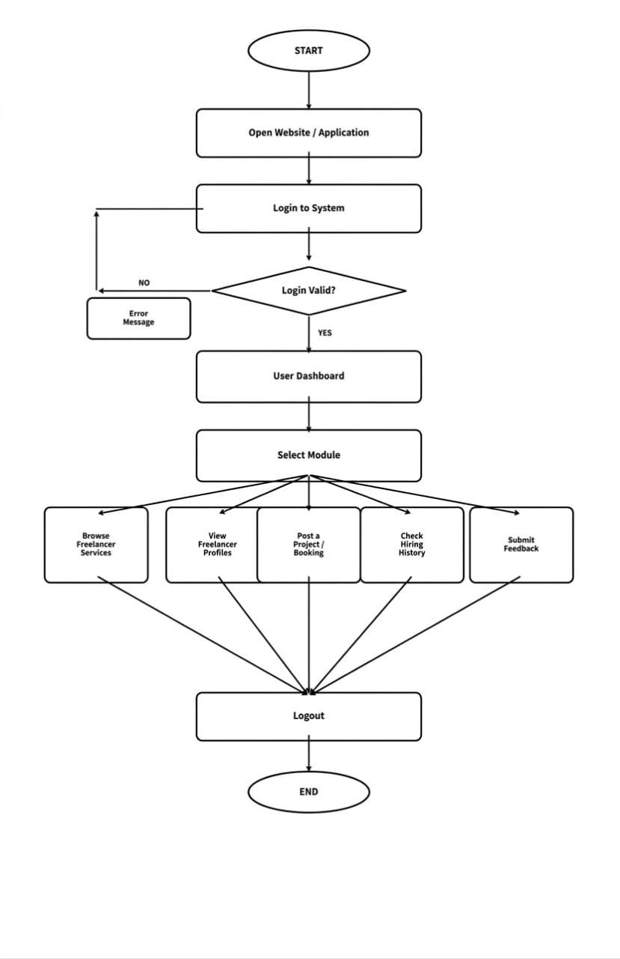
Figure 5.1 Flow diagram of Student Freelancer Marketplace

Figure 5.1, The system flow begins with the Start process, where the user initiates the system and proceeds to log in by entering credentials in the Login to System step. The system then verifies the credentials at the decision point “Login Valid?”. If the login details are correct, the user is granted access and redirected to the Dashboard. However, if the login is invalid, the system displays an error message, prompting the user to try again. Once the user successfully logs in and reaches the dashboard, they are required to select a module through the Select Module option. The system provides several modules, including managing freelancer services, viewing and managing project bookings, accessing customer booking records, maintaining freelancer profiles and pricing, and providing feedback. Each module allows the user to perform specific tasks related to event and freelancer management. After completing the desired operations within any module, the user proceeds to the Logout step. Finally, the process concludes at the End, indicating that the user has exited the system successfully.

User Module Flow:

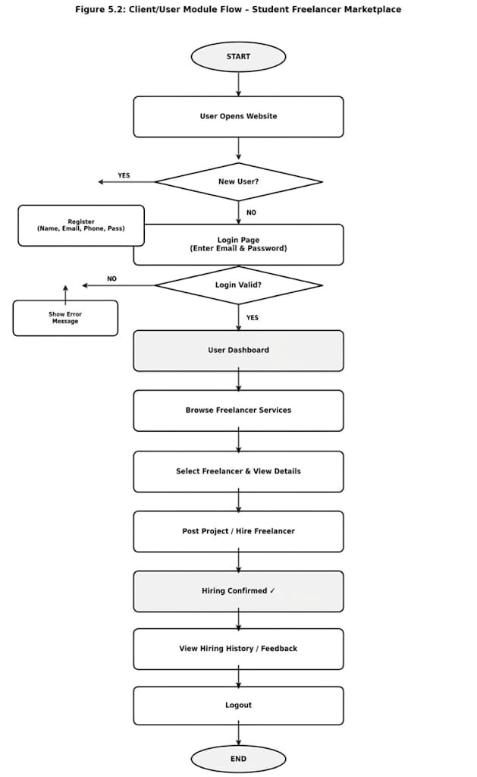

Figure 5.2 Flow diagram of client module.

Fig 5.2, The user module flow of the Student Freelancer Marketplace begins with the Start, where the user opens the website or application and proceeds to Login or Register. The system then checks whether the login credentials are valid. If the credentials are incorrect, an error message is displayed and the user is prompted to log in again. If the login is successful, the user is directed to the User Dashboard.
From the dashboard, the user selects a module based on their needs. The available options include browsing freelancer services, viewing freelancer profiles and prices, booking an event, checking hiring history, and providing feedback. If the user chooses to browse services or view themes, they can select a freelancer and proceed to post a project. During the booking process, the user enters project details and confirms the booking, after which a hire success message is displayed. Additionally, the user can view hiring history to check past project details or submit feedback about the services. After completing the desired actions, the user logs out of the system. Finally, the process ends at the End, indicating the completion of the client session.

Admin Module Flow:

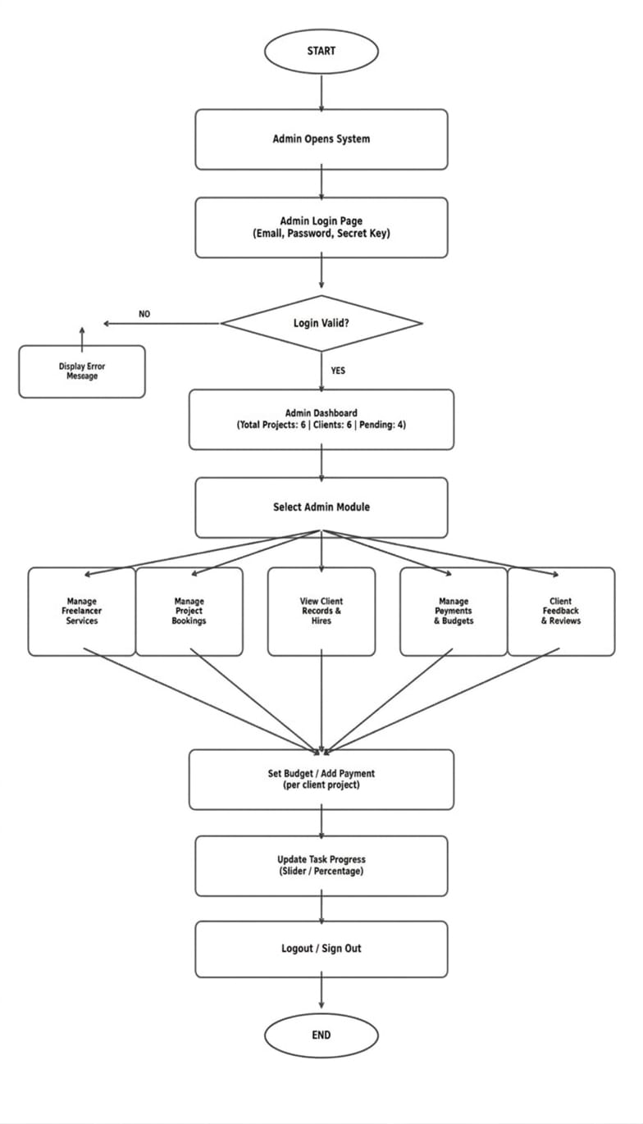

Figure 5.3 Admin module flow

Fig 5.3, The admin module flow of the Student Freelancer Marketplace begins with the Start, where the admin logs into the system through the Admin Login step. The system then verifies the entered credentials at the decision point “Login Valid?”. If the login details are incorrect, an error message is displayed and the admin is prompted to log in again. If the credentials are valid, the admin is granted access to the Admin Dashboard. From the dashboard, the admin selects a module based on the required operation. The system provides several functionalities, including managing freelancer services, managing project bookings, viewing client records, maintaining freelancer profiles and pricing, and reviewing client feedback. In the Manage Freelancer Services module, the admin can add, update, or delete service details. After completing the necessary tasks in any module, the admin proceeds to Logout. Finally, the process ends at the End, indicating that the admin has successfully exited the System.

E-R Diagram:

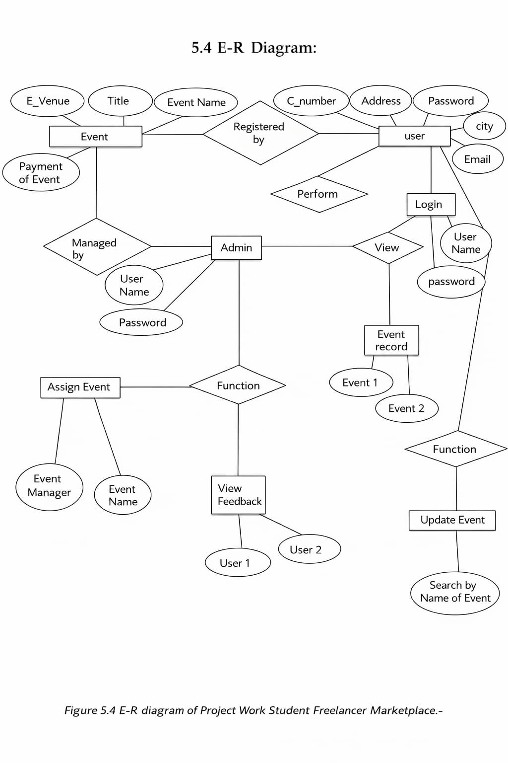

Figure 5.4 E-R diagram of Project Work Student Freelancer Marketplace. –

Table 2 Database table description

Sr No. | Table Name | Fields Name | Purpose
1 | User | Id, name, email, phone, password, address. | Client table stores all registered client details. It helps in authentication and managing user information for bookings.
2 | Admin | Id, email, password, admin_secret_key. | Admin table stores admin login credentials. It ensures secure access and allows only authorized admin to manage the  System.
3 | Browse Freelancers | Id, title, category, profile_image, hourly_rate, description. | Browse Freelancers table contains all freelancer listings with images and details. It helps users explore different freelancer options.
4 | Booking | Id, client_id, listing_id, event_type, event_date, location, status. | Hire table stores project hiring details. It tracks client hires and their current status like pending, accepted, or rejected.
5 | Payment | id, hire_id, amount, payment_method, payment status, payment_date. | Payment table stores transaction details. It helps in managing and tracking payment for each hire.

Sr No. | Table Name | Fields Name | Purpose
6 | Contact | Id, name, email, message, date. | Contact table stores client inquiries and messages. It helps admin respond to user queries.
7 | Reviews | Id, ClientID, rating, comment, date. | Reviews table stores feedback given by users. It helps in showing client reviews and improving service quality.

Functionality provided by System:
- Client Registration and login
- Admin Login and Authentication
- View Decorations Designs (Browse Freelancers)
- Hiring Status Management (Accept/Reject)

1. User Registration and Login

The Client Registration and Login module allows new users to create an account and existing users to access the system securely. It provides a simple and user-friendly interface for easy interaction. In the registration process, users enter details such as name, email, phone number, and password. The system validates the information and stores it securely in the database for future access. For login, users enter their registered email and password. The system verifies these credentials with the stored data. If the details are correct, the user is redirected to the dashboard; otherwise, an error message is displayed. The module also ensures that only authorized users can access the system and perform actions like viewing services, making bookings, and checking hiring status. Overall, this module improves system security, maintains user data, and provides a smooth and reliable login experience.

Stepwise Procedure of User Registration and Login:

- User opens the system.
- User clicks on Registration page.
- User enters details (name, email, phone, password).
- System validates the entered data.
- If valid, user data is stored in database.
- User proceeds to Login page.
- User enters email and password.
- System verifies login credentials.
- If valid, user is redirected to dashboard.
- If invalid, error message is displayed.
- End

Implementation of User Registration and Login:

- Start
- Display Registration/Login Page
- If user is new, then go to Registration
- Enter user details (name, email, phone, password)
- Validate input data
- If valid, store data in database
- Else, display error message
- User enters login credentials
- System verifies username and password
- If valid, redirect to dashboard
- Else, display error message
- User can view/update profile
- User can access services and make bookings
- Admin can view and manage user details

2. Admin Login and Authentication

The Admin Login and Authentication module allows the administrator to securely access the Student Freelancer Marketplace. It ensures that only authorized users can control and manage the system. In this module, the admin enters login credentials such as email, password, and admin secret key. The system validates these details with the stored data in the database. If the entered credentials are correct, the admin is successfully redirected to the dashboard. If the details are incorrect, an error message is displayed to prevent unauthorized access. After successful login, the admin can manage users, bookings, freelancer services, and view reports. This module ensures secure authentication, protects system data, and provides full control to the admin over system operations.

Stepwise Procedure of Admin Login and Authentication:

- Admin opens the system.
- Admin navigates to the Admin Login page.
- Admin enters email, password, and admin secret key.
- System validates the entered credentials.
- System checks data with database records.
- If credentials are valid, admin is redirected to dashboard.
- If credentials are invalid, error message is displayed.
- Admin accesses system features like managing users, bookings, and services.
- Admin performs required operations.
- Admin logs out from the system.
- End

Implementation of Admin Login and Authentication:

- Start
- Display Admin Login Page
- Admin enters email, password, and admin secret key
- Validate input fields
- Check entered data with database records
- If credentials are valid → Redirect to Admin Dashboard
- Else → Display error message
- Allow admin to access system features
- Admin performs required operations
- Admin logs out
- End

3. View Decoration Designs (Gallery)

The Browse Freelancers module allows users to view different freelancer listings available in the Student Freelancer Marketplace. It provides a visually attractive display of various themes and styles for events. Users can explore freelancer listings for different categories such as web projects, design projects, festivals, and corporate events. The freelancer browser displays images along with basic details like skill name, rate, and description. The module also provides filtering options based on category and budget range, helping users to easily find suitable freelancer listings according to their needs. Users can select any design from the freelancer browser to view more details and proceed with booking. This module enhances user experience by providing a wide range of freelancer options in an organized and user-friendly manner
.

Stepwise Procedure of View Freelancer Listing (Freelancer Browser):

- User opens the system.
- User logs in to the system.
- User navigates to the Browse Freelancers page.
- System displays various freelancer listings.
- User selects category (web project, design project, etc.).
- System filters designs based on selected category.
- User can also apply budget filter.
- System displays filtered freelancer listings.
- User selects a design to view details.
- User proceeds to booking if interested.
- End

Implementation of View Freelancer Listings (Freelancer Browser):

- Start
- User logs in to the system
- Display Browse Freelancers Page
- Fetch decoration data from database
- Display all freelancer listings
- User selects category filter
- Filter designs based on category
- User applies budget filter (optional)
- Display filtered designs
- User selects a design
- Display design details
- If user clicks "Hire Now" → redirect to booking form
- End

4. Hiring Status Management (Accept/Reject)

The Hiring Status Management module allows the admin to manage all project hiring requests efficiently. It helps in controlling and updating the status of each booking. When a user submits a hiring request, it is stored in the database with a pending status. The admin can view all hiring details from the dashboard. The admin has the option to either accept or reject the booking based on availability and requirements. If accepted, the hiring status is updated to "Accepted," and if rejected, it is updated to "Rejected." The updated status is reflected in the user's account, allowing users to check their hiring status easily. This module ensures proper management of bookings, reduces confusion, and improves communication between admin and users.

Stepwise Procedure for Hiring Status Management (Accept/Reject):

- User submits hiring request.
- System stores booking with "Pending" status in database.
- Admin logs in to the system.
- Admin navigates to hiring management section.
- System displays all hiring requests.
- Admin selects a booking.
- Admin views hiring details.
- Admin decides to accept or reject the booking. If accepted → update status to "Accepted". If rejected → update status to "Rejected".
- System updates status in database.
- User can view updated hiring status.
- End

Implementation of Hiring Status Management (Accept/Reject):

- Start
- User submits hiring request
- Store booking in database with "Pending" status
- Admin logs in to the system
- Display all hiring requests
- Admin selects a booking
- Display hiring details
- Admin chooses Accept or Reject
- If accept → update status to "Accepted"
- Else → update status to "Rejected"
- Update hiring status in database
- Display updated status to user
- End

Result and Application

Result:

Home Page:



Figure 6.3 Home page
The Home Page is the main interface of the Student Freelancer Marketplace. It provides an attractive and user-friendly overview of freelancer services with a clean and modern design. This page includes a navigation bar with options like Home, Browse Freelancers, Client Reviews, and Contact Us, which helps users easily access different sections of the website. It displays featured freelancer listings and highlights the purpose of the system, allowing users to understand the services offered. The “Explore Freelancers” and “Our Services” buttons guide users to view available decorations and proceed with booking. The page also plays an important role in engaging users by showing visually appealing images and giving a clear idea about freelancer marketplace themes and services. Overall, the Home Page improves user experience by providing easy navigation, clear information, quick access to important features, and a smooth starting point for exploring the system.

Browse Freelancers Page:

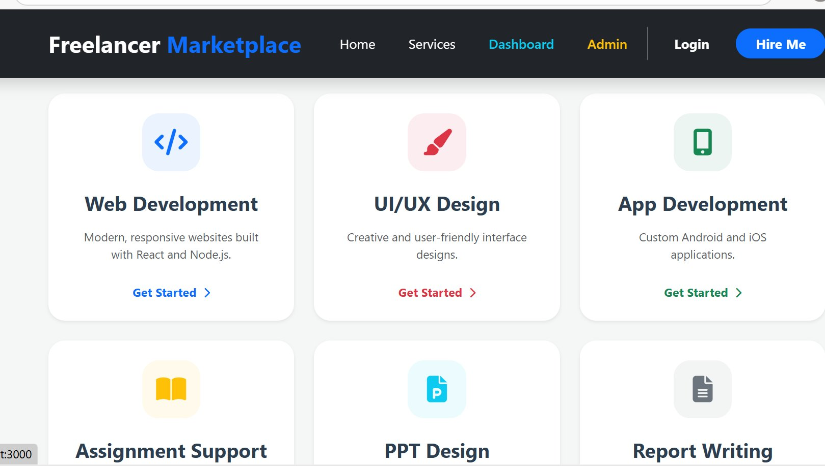

Figure 6.4 Browse Freelancers page.

The Browse Freelancers Page is an important part of the Student Freelancer Marketplace. It provides a collection of different freelancer listings in a organized and user-friendly layout. This page includes a navigation bar and category filters such as Web Development, Design, Writing, Marketing, and Consulting, which help users easily find specific freelancer categories. It displays multiple freelancer listings with images and basic details, allowing clients to explore various skills and services offered by freelancers. Users can select any design to view more details and proceed with booking. The page also includes filtering options like budget and skill level, which helps users choose designs according to their requirements. Overall, the Browse Freelancers Page improves user experience by providing organized, easy navigation, and a wide variety of freelancer options in one place.

Client Login Page:

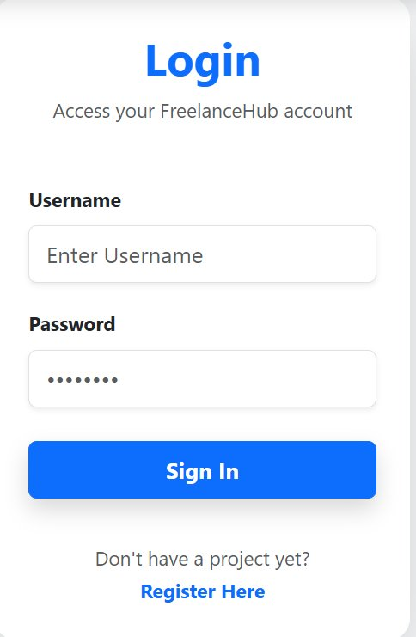
Figure 6.7 Client Review Page.
The Student Freelance Marketplace Login page is a clean and simple user interface designed to allow registered users to securely access the Student Freelancer Marketplace platform. The page follows a card-based layout where a white rounded card is placed at the centre of a light gray background, giving it a modern and professional appearance.
At the top of the card, the word "Login" is displayed in large bold blue text, which immediately tells the user the purpose of the page. Just below the title, a subtitle reads "Access your Freelance Hub account" in small Gray text, indicating the name of the platform. Below the title section, there are two input fields. The first field is labelled "Username" in bold black text, with an input box below it showing placeholder text "Enter Username" in light Gray. The second field is labelled "Password" in bold black text, and its input box displays masked dots (••••••••), meaning the entered password is hidden for privacy and security

My Hires Page:

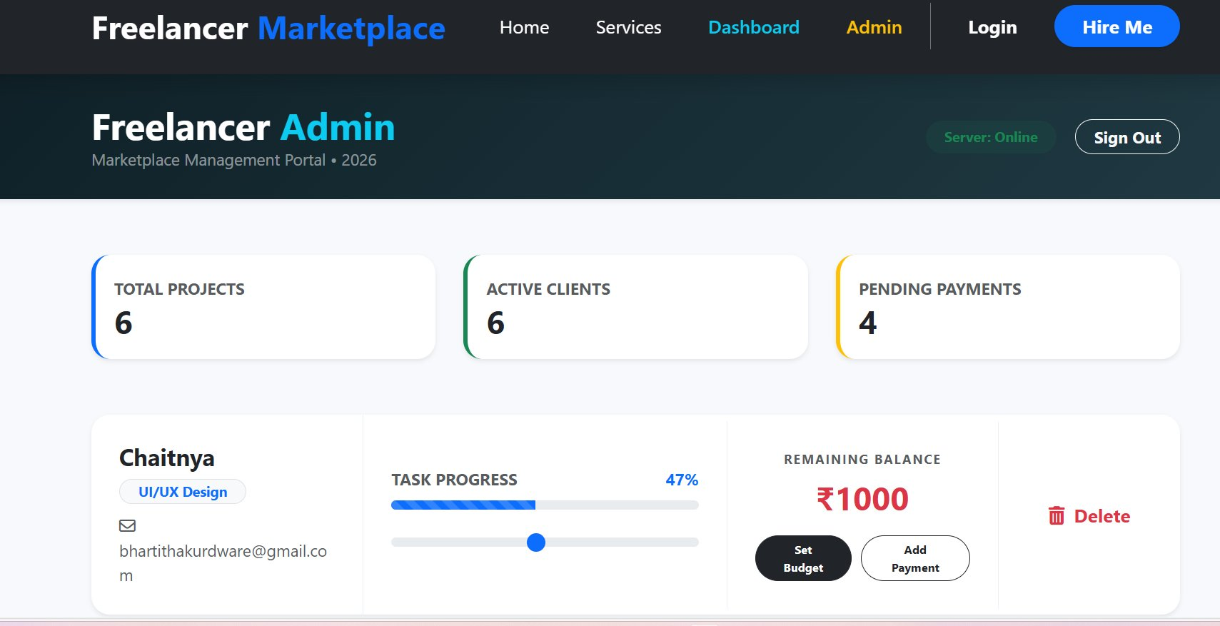
Figure 6.8 My Hires page.

The My Hires Page allows users to view and manage all their project bookings in the Student Freelancer Marketplace. It provides a clear and organized overview of hiring details and status in one place. This page displays summary information such as total hires, pending approvals, and notifications, helping users stay updated about their booking activities. It makes tracking bookings simple and quick. The “My Recent Hires” section shows detailed information including event name, date, time, selected freelancer, and hiring status like accepted, pending, or rejected. Users can easily check the progress of their bookings. This page may also allow users to view hiring details, cancel hires (if allowed), or take further actions based on status updates. Overall, the My Hires Page enhances user convenience by providing real-time updates, easy navigation, and efficient management of project bookings in a user-friendly interface.

Contact Page:


Figure 6.9 Contact page.
The Contact Page of the Student Freelancer Marketplace allows users to communicate directly with the service provider. It provides all necessary contact details and a form to send inquiries or requirements easily. This page includes contact information such as phone numbers, email addresses, and working hours. Users can use these details to connect with the team for any queries or support related to freelancer services. The page also contains a “Post Your Project” form where users can enter their full name, phone number, email address, and project type. This helps the system collect important details about the client’s requirements. Users can also specify project deadline, budget range, and additional project details in the form. This information helps the admin understand client requirements clearly and provide better service. Overall, the Contact Page improves communication between users and the service provider.

Dashboard - Admin:


Figure 6.10 Dashboard.

The Admin Dashboard is the main control panel of the Student Freelancer Marketplace. It provides an overview of all system activities and helps the admin manage operations efficiently. This page displays important information such as total hires, pending reviews, accepted projects, and active freelancers. It allows the admin to quickly understand the current status of the system. The dashboard also shows skills details and alerts, helping the admin manage freelancers’ items and avoid shortages. This improves planning and resource management. On the left side, a navigation menu is provided with options like Dashboard, Manage Hires, Project Calendar, Manage Freelancerss, Client Reviews, Skills, and Payments. This makes it easy to access different modules. Overall, the Admin Dashboard improves efficiency by providing quick insights, easy navigation, and better control over bookings, users, and freelancer services.

Chapter 7

Testing (Student Freelancer Marketplace)

7.1 Introduction

This chapter covers the testing activities performed for the Web Application for Student Freelancer Marketplace. Testing of this system is important because it is used for managing project bookings, freelancer services, payments, and user interactions including customers and admin.

The objective of this testing phase is to verify that all functionalities work correctly across all users. The system should allow valid users to register and log in successfully, book freelancer marketplace services, manage hires, and handle payments.

It must also:

Reject unauthorized access

Validate all required inputs

Handle incorrect data properly

Testing includes:

Positive scenarios (successful login, booking, payment)

Negative scenarios (invalid input, empty fields)

Testing tools used:

Selenium IDE

Selenium WebDriver

Out of Scope:

Advanced payment gateway testing

Third-party API performance testing

7.2 Test Plan (Registration Module)

Test Plan: Student Freelancer Marketplace

Version: 1.0

Test Plan ID: TP_REG_01

1. Introduction

This test plan verifies that the registration module works correctly. It ensures that new users (Customer/Admin) can register successfully with valid inputs.

2. Test Items

Registration form UI

Name, Email, Mobile validation

Password validation

Role selection (Customer/Admin)

Data storage

3. Features to be Tested

Valid registration

Invalid inputs

Empty field validation

Duplicate email validation

Password strength

4. Features Not to be Tested

Payment system

Event booking

Admin dashboard

5. Approach

Manual + Automation testing

Positive & Negative testing

UI validation

6. Pass / Fail Criteria

All test cases must pass

No critical bugs

Expected results = Actual results

7. Suspension Criteria

Testing stops if major bugs occur

Resume after fixing

8. Test Deliverables

Test plan

Test cases

Defect report

Test summary

9. Test Tasks

Prepare test cases

Execute testing

Find defects

Retest

10. Test Environment

OS: Windows 11

Browser: Chrome, Edge

Frontend: HTML, CSS, JS

Backend: Node.js

Database: MongoDB

11. Responsibilities

QA Tester → Testing

Developer → Bug fix

Manager → Approval

12.Staffing and Training
- Requires knowledge of registration module functionality, testing techniques, and Selenium tools.

13. Scheduling

Project deadline: As per project submission

14. Risks

Invalid test data

Browser issues

Requirement changes

15. Approvals

Project Guide, Team Members

Test Cases: -

Test Case ID | Objective | Input (Steps) | Expected Result | Actual Result | Status
TC_REG_001 | Registration with valid data | Name: ABC Email: abc@gmail.com Mobile: 1234567897 Password: abc@123 Role: Customer | User should register successfully and data saved in database | User registered successfully and data saved | Pass
TC_REG_002 | Registration with empty field | All fields blank | System should display "Please fill all fields" | Message displayed correctly. | Pass
TC_REG_003 | Registration with invalid email | Email: abc123 | System should display "Invalid email format" | Error message displayed. | Pass
TC_REG_004 | Registration with empty password | Password: (empty) | System Should Display "password is required" | Message displayed | Pass
TC_REG_005 | Registration with weak password | Password: 12345 | System Should display "Weak password" | Message displayed correctly | Pass
TC_REG_006 | Registration with duplicate email | Email already registered | System should display "Email already exists" | Error message displayed | Pass
TC_REG_007 | Registration with invalid mobile number | Mobile: 1234 | System should display "Invalid mobile number" | Error Message displayed | Pass
TC_REG_008 | Role selection validation | No role selected | System should display "Please select role" | Message displayed | Pass
TC_REG_009 | Registration as Customer | Valid details + Role: Customer | User should register Successfully as Customer | Registered successfully | Pass
TC_REG_010 | Multiple registration attempts restriction | Enter invalid/duplicate data multiple times and click Register repeatedly. | System should restrict multiple registration attempts or display warning message for security | System allows unlimited registration attempts without any restriction | Fail

Table 7.1 Test Cases (Registration Module)

7.3 Defect Report
The defect report is a crucial document used to record and track defects identified during the testing process of the Student Freelancer Marketplace. It provides detailed information about each defect, including its description, severity, priority, steps to reproduce, and current status.
This report helps the development and testing teams to understand, prioritize, and resolve issues efficiently. It also ensures effective communication among team members and maintains transparency throughout the defect management process.

Defect ID | DR_SFM_0010
Project Name | Student Freelancer Marketplace
Product | Web Application
Release Version | v1.0
Module | Client Registration Module
Detected Build Version | v1.1
Summary | System allows unlimited client registration attempts without restriction
Description | While testing the Client Registration module of the Student Freelancer Marketplace, it was observed that the system does not impose any limit on the number of registration attempts. When a user enters invalid, duplicate, or incomplete information multiple times and repeatedly clicks on the "Register" button, the system continues to process each request without any validation lock, CAPTCHA, delay mechanism, or warning message.
Actual Result | System allows unlimited registration attempts without any restriction
Expected Result | System should validate and prevent unlimited attempts by displaying an appropriate error message or implementing CAPTCHA/lock mechanism
Severity | Medium (Functional issue affecting data accuracy)
Priority | High (Important to fix for correct booking workflow)
Reported By | Test Engineer
Status | Open

Conclusion and Future Scope

Conclusion:

The Student Freelancer Marketplace is developed to simplify the process of managing freelancer marketplace services and bookings. The system helps users explore different freelancer profiles and hire freelancers easily through an online platform. It also helps the admin manage freelancer services and booking records in an organized way. Overall, the system improves efficiency, saves time, and provides a better experience for both users and administrators.
This system reduces manual work and helps maintain event and client information in a structured database. It also provides a user-friendly interface for both admin and users to manage freelancer marketplace services effectively. The project demonstrates how web-based technology can be used to improve freelancer management and project hiring processes.

Future Scope:

- The system can be developed as a mobile application for easier access.
- Online payment options can be added for project bookings.
- More freelancer profiles and event services can be included in the system.
- Notification features such as email or SMS alerts can be added for booking updates.
- The system can be expanded to support more clients and different types of projects.

Reference and Bibliography

Reference:

Books
    - Software Engineering: A Practitioner’s Approach (Eight Edition by Roger S. Pressman, Ph.D. & Bruce R. Maxim, Ph.D.)

Websites
    - CSS Tutorial -www.w3schools.com
    - PHP Tutorial -www.w3schools.com
    - Bootstrap 3 Tutorial -www.w3schools.com
    - PHP Tutorial – www.Tutorialspoint.com
    - Detail implementation of Html -https://developer.mozilla.org/en-US/
    - Block diagram – https://staruml.io

Bibliography:

Existing project monitoring process review:
DEPARTMENT OF COMPUTER ENGINEERING
S.S.V.P. S’s Bapusaheb Shivajirao Deore Polytechnic, Dh

